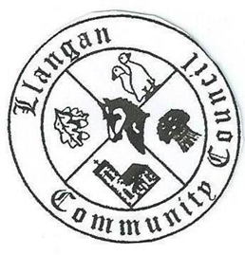
Cyngor Cymuned a Llangan

The ANNUAL GENERAL MEETING of Llangan Community Council will take place on TUESDAY 6th October 2020 via Zoom, at 7.00pm

AGENDA

- Attendance, apologies for absence, minutes of AGM 11th June 2019 and Clerk’s note to the AGM

- Election of Officers for the year 2020-21:
- Election of Chairman
- Election of Vice – Chairman

- Appointment of any new committees, confirmation of the terms of reference, the number of members (including, if appropriate, substitute councillors) and receipt of nominations to them.

- Election of representatives to:
- Representatives of Treoes Community Hall
- Representatives of Llangan Community Hall
- School Governor at Llangan Primary School
- Community Liaison Representative (+1 reserve)
- OVW Local Representative

- Review of Annual Report for year ended March 2020

- Review and adoption of Standing Orders, councillors’ expenses policy, Code of Conduct, Risk Management policy, Welsh Language policy, Use of Social Media policy, Concerns and Complaints policy and Financial Regulations

- Review and adoption of policy documents in respect to the GDPR

- Review and confirmation of arrangements for insurance cover in respect of
all insured risks

- Annual Review of the Clerk’s salary, performance and terms of conditions (Clerk required to leave the room)

- Setting the dates, times and place of ordinary meetings of the full Council for
the year ahead.

Kevin Protheroe, Clerk to the Council October 2020

