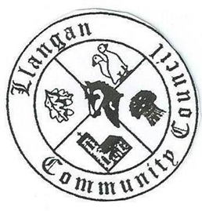Llangan Community Council - Cyngor Cymuned a Llangan
COUNCIL SUMMONS
The next Ordinary General Meeting will be held via Zoom on Tuesday 3rd November 2020 at 7:00PM
AGENDA
1. | Welcome, record of councillors present and apologies for absence
2. | Disclosure and confirmation of declarations of interest
3. | To receive minutes of 6th October 2020 Ordinary General Meeting
4 | To consider any Matters arising from the 6th October 2020 Ordinary General Meeting not covered elsewhere in the agenda
5. | Public session
6. | To consider Police matters
7. | To consider County Council Matters
8. | Code of Conduct and Local Resolution procedure
9. | LCC defibrillators: Update
10. | To consider Community Centre Reports on Llangan and Treoes Halls including Llangan extension
11. | Quarter 2 Management Accounts 2020/21
12. | To consider the Clerk’s report including matters of a financial nature and planning
13. | Planning matters
14. | To consider any correspondence and associated replies required
15. | Re-commencement of meetings in person
16. | Treoes Allotments: Update
17. | To receive any announcements from Councillors
18. | Date and time of next meeting

Kevin Protheore
Clerk to the Council October 2020

