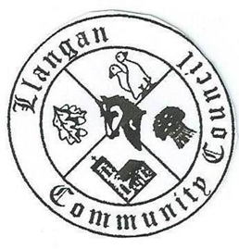Llangan Community Council - Cyngor Cymuned a Llangan
COUNCIL SUMMONS
The next Ordinary General Meeting will be held via Zoom on Tuesday 1st December 2020 at 7:00PM
AGENDA
1. | Welcome, record of councillors present and apologies for absence
2. | Disclosure and confirmation of declarations of interest
3. | Yr Efail field play area: Resolution of adoption issues (In attendance officers of the Vale of Glamorgan Borough Council)
4 | To receive minutes of 3rd November 2020 Ordinary General Meeting
5. | To consider any Matters arising from the 3rd November 2020 Ordinary General Meeting not covered elsewhere in the agenda
6. | Public session
7. | To consider Police matters
8. | To consider County Council Matters
9. | Highway issues: priority proposals
10. | Village Greens proposals: update
11. | Cwrt Canna: Lettings policy
12. | To consider Community Centre Reports on Llangan and Treoes Halls including Llangan extension
13. | LCC defibrillators: Update
14. | To consider the Clerk’s report including matters of a financial nature
15. | Planning matters
16. | To consider any correspondence and associated replies required
17. | Treoes Allotments: Update
18. | To receive any announcements from Councillors
19. | Date and time of next meeting

Kevin Protheore
Clerk to the Council December 2020

