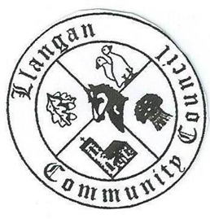Llangan Community Council - Cyngor Cymuned a Llangan
COUNCIL SUMMONS
The next Ordinary General Meeting will be held via Zoom on Tuesday 2nd February 2021 at 7:00PM
AGENDA
1. | Welcome, record of councillors present and apologies for absence
2. | Disclosure and confirmation of declarations of interest
3. | To receive minutes of 12th January 2021 Ordinary General Meeting
4 | To consider any Matters arising from the 12th January 2021 Ordinary General Meeting not covered elsewhere in the agenda
5. | Public session
6. | To consider Police matters
7. | To consider County Council Matters
8. | Quarter 3 Management Accounts 2020/21
9. | Budget 2021/22
10. | To consider Community Centre Reports on Llangan and Treoes Halls including Llangan extension
11. | To consider the Clerk’s report including matters of a financial nature
12. | Planning matters
13. | To consider any correspondence and associated replies required
14. | Treoes Allotments: Update
15. | To receive any announcements from Councillors
16. | Date and time of next meeting

Kevin Protheore
Clerk to the Council February 2021

