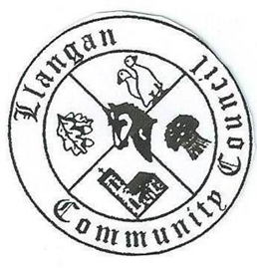Llangan Community Council - Cyngor Cymuned a Llangan
COUNCIL SUMMONS
The next Ordinary General Meeting will be held via Zoom on Tuesday 6th April 2021 at 7:00PM
AGENDA
1.21/22 | Welcome, record of councillors present and apologies for absence
2.21/22 | Disclosure and confirmation of declarations of interest
3.21/22 | To receive minutes 2nd March 2021 Ordinary General Meeting for:  - Accuracy  - Approval
4.21/22 | To consider any Matters arising from the 2nd March 2021 Ordinary General Meeting not covered elsewhere in the agenda
5.21/22 | Public session
6.21/22 | To consider Police matters
7.21/22 | To consider County Council Matters
8.21/22 | Section 137 Grant applications
9.21/22 | Highway/Road Safety issues: Response from Vale of Glamorgan Council
10.21/22 | To consider Community Centre Reports on Llangan and Treoes Halls including Llangan extension
11.21/22 | To consider the Clerk’s report including matters of a financial nature
12.21/22 | Planning matters
13.21/22 | To consider any correspondence and associated replies required
14.21/22 | Treoes Allotments: Update
15.21/22 | To receive any announcements from Councillors (Schedule of Meetings 2021/22)
16.21/22 | Adverse possession application: Land to the south of the Croft, Llangan
17.21/22 | Date and time of next meeting

Kevin Protheore
Clerk to the Council April 2021

