**Llangan Community Council**

**Annual Report April 2019 to March 2020**

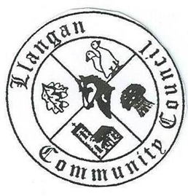

During the year the Community Council continued to work on behalf of the local community throughout the year on a variety of issues. The volunteer community councillors were assisted by several other groups and individuals, notably Cllr Christine Cave and the Vale of Glamorgan Council.

This report highlights the main achievements and activities of the Council throughout the year.

**Llangan Community Council’s Aims and Objectives**

The Council’s key aims are:

* To act as a link between public sector organisations and the community on a range of subjects including the environment, planning, community facilities, community safety and other issues affecting the area
* To develop a picture of community needs in order to influence services and policies
* To represent the views of the community
* Provide a wide range of advice, information and support for the community and local voluntary groups
* Identify concerns and issues and seek to develop solutions with other partner organisations
* Support community projects and groups

**The Council’s Activities in 2019- 2020**

**Secured major improvements to community facilities and services**

* 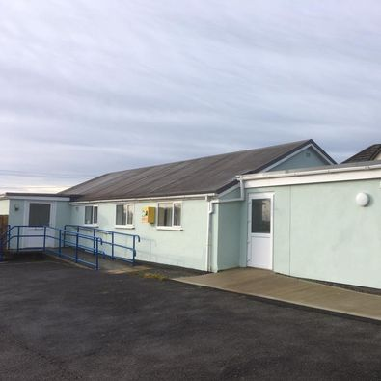The council enabled significant improvements to Llangan and St Mary Hill Community Hall by securing £56,000 in grant funding from the Welsh European Funding Office and £14,000 from the Vale of Glamorgan Council via Section 106 Planning funds
* In partnership with the Vale of Glamorgan Council, the council improved children’s play facilities at Fferm Goch (pictured below) and the area received £85,000 towards a new play area for children in Treoes (to start in 2021)

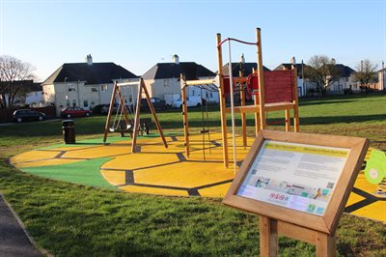

* Supported residents by administering and assisting to organise the advent of digital broadband to the village of Llangan
* Supported the Friends of Lllangan School in creating an outdoor play area at Llangan school by providing a grant for materials and equipment

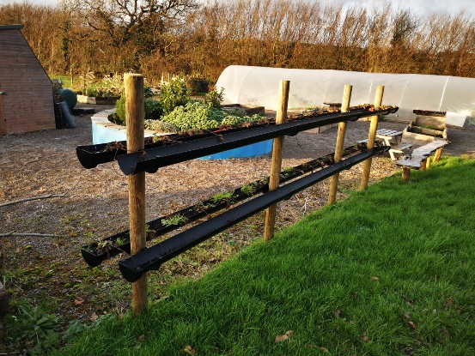

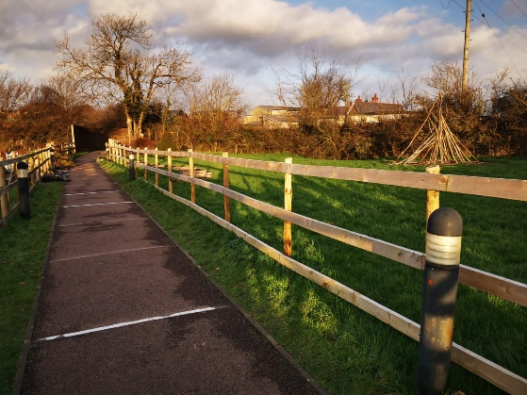

* Took steps to establish the Yr Efail pathway as a public right of way to benefit the local community
* Launched a new website, grant-funded by the Creative Rural Communities initiative, focussing on both the Community Council and the communities it serves. <https://www.llangancouncil.co.uk/>

**Provided assistance to local community groups**

* Provided financial support to the Old School Rooms, Llangan for maintenance of the grounds
* Provided financial support for Saron Independent Chapel which enabled them to create a new Heritage Hub, as well as maintenance of the grounds

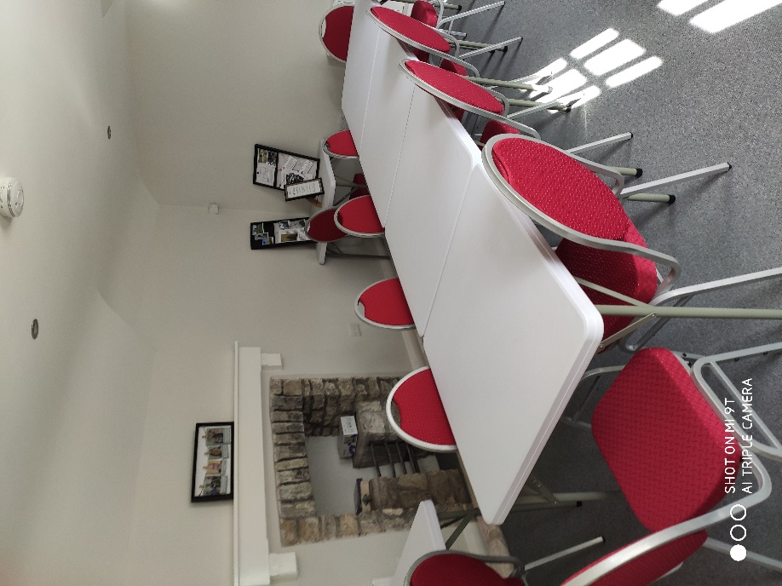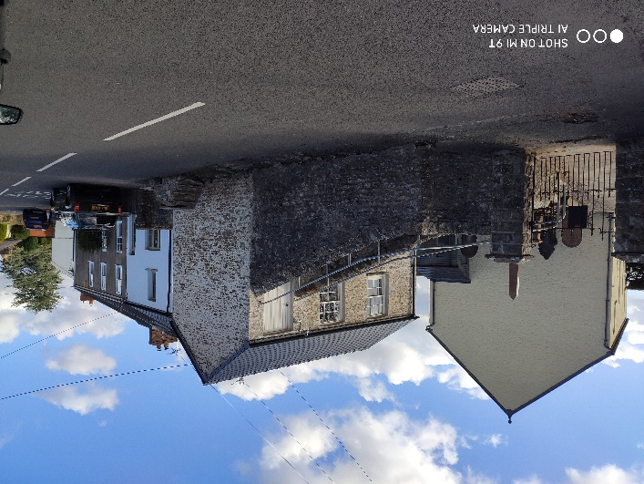

* Supported the community halls in Llangan/St Mary Hill and Treoes, where community councillors act as trustees
* Supported Llangan Primary School, where a community councillor is a member of the Board of Governors

**Pushed for improvements on issues impacting the local community**

* Tackled numerous local issues, which were a concern to residents notably in respect of highway issues such as road conditions, speeding traffic, large HGVs using the villages as ‘rat runs’
* Responded to all planning issues requiring their consideration, on time. They devoted time, in particular, to the proposed extension of the extraction time limit at Ruthin and Garwa quarries. The Community Council objected to the application due to concerns regarding their impact on the local communities, the environment, and the additional traffic
* Met and corresponded regularly with the Vale of Glamorgan Council on local issues such as the new housing development at Cwrt Canna
* Maintained close contact with the local Police so that issues of concern were addressed quickly. Fortunately, crime in the area remains extremely low

**Maintained standards of governance and accountability**

* Administered its own affairs effectively, as evidenced by both internal and external audits, ensured good governance and held regular monthly meetings, often attended by members of the public. The Community Council filled one vacancy during the year
* The Community Council’s main funding in 2019/20 was the Precept of £10,260 and the Council recorded a deficit in its accounts of £12,275.29, which has reduced the accumulated surplus from £35,757 to £23,482. However, the accounts were actually in surplus of £3,029.21. This is because the Community Council received £15.3k from local residents in 2018/19 for the broadband project and spent that sum in 2019/20 on the broadband project
* No member of the Community Council received more than £150 to enable them to pay for basic sundries