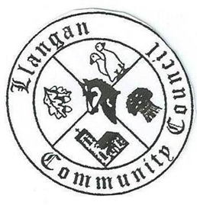Llangan Community Council - Cyngor Cymuned a Llangan
COUNCIL SUMMONS
The next Ordinary General Meeting will be held via Zoom on Tuesday 8th June 2021 at 7:30PM
AGENDA
1. | Welcome, record of councillors present and apologies for absence
2. | Disclosure and confirmation of declarations of interest
3. | To receive minutes 4th May 2021 Ordinary General Meeting for:  - Accuracy  - Approval
4. | To consider any Matters arising from the 4th May 2021 Ordinary General Meeting not covered elsewhere in the agenda
5. | Public session
6. | To consider Police matters
7. | To consider County Council Matters
8. | To consider Community Centre Reports on Llangan and Treoes Halls including Llangan extension
9. | To consider the Clerk’s report including matters of a financial nature
10. | Planning matters
11. | Llangan Place Plans: Draft report (Cllr Reed)
12. | To consider any correspondence and associated replies required
13. | Treoes Allotments: Update
14. | To receive any announcements from Councillors  - Tree planting and biodiversity, Fferm Goch Park
15. | Date and time of next meeting

Kevin Protheore
Clerk to the Council June 2021

