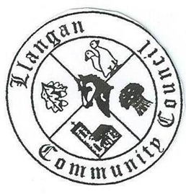Llangan Community Council - Cyngor Cymuned a Llangan
COUNCIL SUMMONS
The next Ordinary General Meeting will be held via Zoom on Tuesday 14th September 2021 at 7:00PM
AGENDA
1. | Welcome, record of councillors present and apologies for absence
2. | Disclosure and confirmation of declarations of interest
3. | To receive minutes 8th June 2021 Ordinary General Meeting for:  - Accuracy  - Approval
4. | To consider any Matters arising from the 8th June 2021 Ordinary General Meeting not covered elsewhere in the agenda
5. | Public session
6. | To consider Police matters
7. | To consider County Council Matters
8. | To consider Community Centre Reports on Llangan and Treoes Halls including Llangan extension
9. | Welsh Government consultations:  - Public consultation on changing the default speed limit on residential streets from 30mph to 20mph is now open until 1st October 2021  - ‘Eligible Community Councils (General Power of Competence) (Qualifications of Clerks) (Wales) Regulations 2021’ is now open until 24th September 2021
10. | To consider the Clerk’s report including matters of a financial nature
11. | Management Accounts Quarter 1 2021/22
12. | Draft Grants Policy
13. | Planning matters
14. | Llangan Place Plans
15. | To consider any correspondence and associated replies required
16. | Treoes Allotments: Update
17. | To receive any announcements from Councillors  - Tree planting and biodiversity, Fferm Goch Park  - Treoes Moors – boulders adjacent to highway
18. | Date and time of next meeting

Kevin Protheore
Clerk to the Council September 2021

