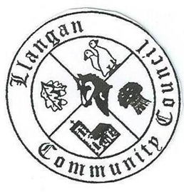Llangan Community Council - Cyngor Cymuned a Llangan
COUNCIL SUMMONS
The next Ordinary General Meeting will be held via Zoom on Tuesday 11th January 2022 at 7:00PM
AGENDA
1. | Welcome, record of councillors present and apologies for absence
2. | Disclosure and confirmation of declarations of interest
3. | To receive minutes 7th December 2021 Ordinary General Meeting for:  - Accuracy  - Approval
4. | To consider any Matters arising from 7th December 2021 Ordinary General Meeting not covered elsewhere in the agenda
5. | Public session
6. | To consider Police matters
7. | To consider County Council Matters
8. | Precept and Budget 2022/23
9. | To consider Community Centre Reports on Llangan and Treoes Halls including Llangan extension:  - Llangan Hall lease  - Treoes Hall lease
10. | To consider the Clerk’s report including matters of a financial nature
11. | Planning matters
12. | To consider any correspondence and associated replies required
13. | To receive any announcements from Councillors:
 | Date and time of next meeting

Kevin Protheroe
Clerk to the Council January 2022

