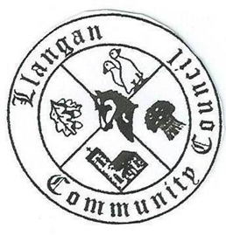Llangan Community Council - Cyngor Cymuned a Llangan
COUNCIL SUMMONS
The next Ordinary General Meeting will be held via Zoom on Tuesday 5th April 2022 at 7:00PM
AGENDA
1. | Welcome, record of councillors present and apologies for absence
2. | Disclosure and confirmation of declarations of interest
3. | To receive minutes 8th March 2022 Ordinary General Meeting for:  - Accuracy  - Approval
4. | To consider any Matters arising from 8th March 2022 Ordinary General Meeting not covered elsewhere in the agenda
5. | Public session
6. | To consider Police matters
7. | To consider County Council Matters:
8. | Buildings, land, and allotments report including Llangan and Treoes Halls:
9. | Section 137 Grant application: The Old School Room, Llangan
10. | To consider the Clerk’s report including matters of a financial nature
11. | Planning matters
12. | To consider any correspondence and associated replies required
13. | To receive any announcements from Councillors:
14. | Date and time of next meeting

Kevin Protheroe
Clerk to the Council April 2022

