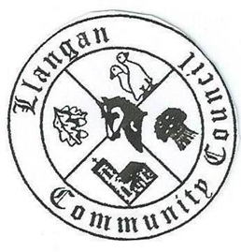Llangan Community Council - Cyngor Cymuned a Llangan
COUNCIL SUMMONS
The next Ordinary General Meeting will be held via Zoom on Tuesday 8th March 2022 at 7:00PM
AGENDA
1. | Welcome, record of councillors present and apologies for absence
2. | Disclosure and confirmation of declarations of interest
3. | To receive minutes 1st February 2022 Ordinary General Meeting for:  - Accuracy  - Approval
4. | To consider any Matters arising from 1st February 2022 Ordinary General Meeting not covered elsewhere in the agenda
5. | Public session
6. | To consider Police matters
7. | To consider County Council Matters:  - Active Travel Route Consultation  - Legal Service Level Agreement with VOGC
8. | Buildings, land, and allotments report including Llangan and Treoes Halls:  - Adverse Possession: Land to the south of the Croft Llangan: Update  - Parc Newydd: Update  - Hall leases: Update  - Llangan Hall outstanding contract works: Update
9. | To consider the Clerk’s report including matters of a financial nature
10. | Planning matters
11. | To consider any correspondence and associated replies required
12. | To receive any announcements from Councillors:
13. | Date and time of next meeting

Kevin Protheroe
Clerk to the Council March 2022

