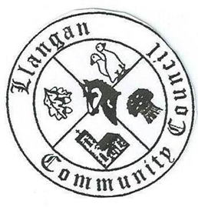Llangan Community Council - Cyngor Cymuned a Llangan
COUNCIL SUMMONS
The next Ordinary General Meeting will be held via Zoom on Tuesday 7th June 2022 at 7:15PM
AGENDA
1. | Welcome, record of councillors present and apologies for absence
2. | Disclosure and confirmation of declarations of interest
3. | To receive minutes 3rd May 2022 Ordinary General Meeting for:  - Accuracy  - Approval
4. | To consider any Matters arising from 3rd May 2022 Ordinary General Meeting not covered elsewhere in the agenda
5. | Public session
6. | To consider Police matters
7. | To consider County Council Matters
8. | Co-option arrangements for Community Council
9. | Buildings, land, and allotments report including Llangan and Treoes Halls:  - Land South of the Croft, Llangan: Report from Cllr Reed  - Llangan and Treoes Hall leases: Update
10. | Management Accounts: Year End 2021/22
11. | The Local Government and Elections (Wales) Act 2021: Impact on community councils
12. | To consider the Clerk’s report including matters of a financial nature
13. | Planning matters
14. | To consider any correspondence and associated replies required
15. | To receive any announcements from Councillors:
16. | Date and time of next meeting

Kevin Protheroe
Clerk to the Council June 2022

