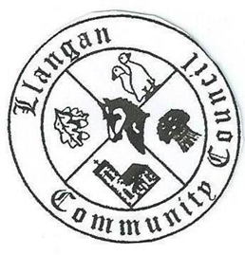Llangan Community Council - Cyngor Cymuned a Llangan
COUNCIL SUMMONS
The next Ordinary General Meeting will be held via Zoom on Tuesday 12th January 2021 at 7:00PM
AGENDA
1. | Welcome, record of councillors present and apologies for absence
2. | Disclosure and confirmation of declarations of interest
3. | To receive minutes of 1st December 2020 Ordinary General Meeting
4 | To consider any Matters arising from the 1st December 2020 Ordinary General Meeting not covered elsewhere in the agenda
5. | Public session
6. | To consider Police matters
7. | To consider County Council Matters
8. | Precept 2021/22
9. | Highway issues: priority proposals: VOGC’s response
10. | To consider Community Centre Reports on Llangan and Treoes Halls including Llangan extension
11. | Annual Report 2020/21
12. | To consider the Clerk’s report including matters of a financial nature
13. | Planning matters
14. | To consider any correspondence and associated replies required
15. | Treoes Allotments: Update
16. | To receive any announcements from Councillors
17. | Date and time of next meeting

Kevin Protheore
Clerk to the Council January 2021

